Reading
Tariq’s email
<SB S.XXX>

Read Tariqs email. Lies Tariqs E-Mail.
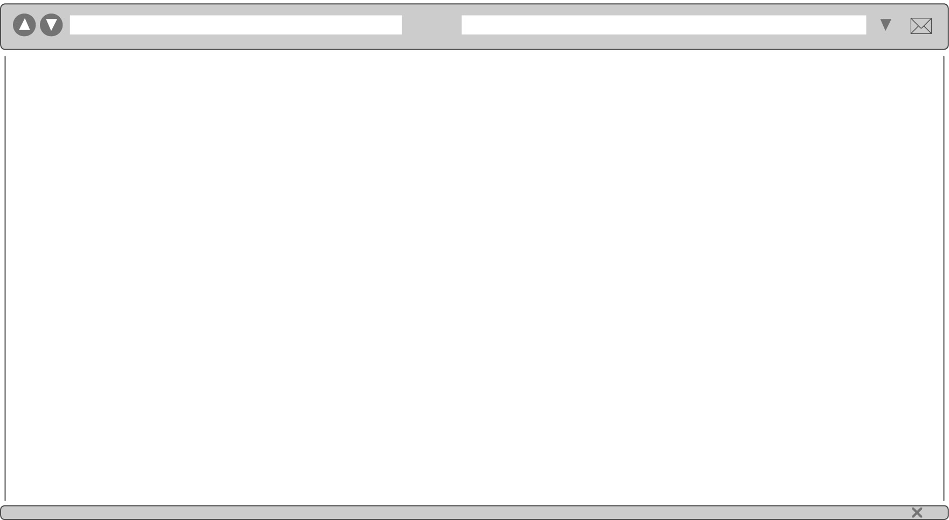

Hi!
My name is Tariq. I’m from Notting Hill. That’s in London. I’m twelve. My parents are from India. I like playing basketball and I am a good cook. I have got a pet, too. It is a dog. Its name is Olive. My best friends are Martha and Jonathan.
What about you and your area?

Write back soon,
Tariq ☺

Now read these sentences. Tick (✓) right or wrong.
Lies die Aussagen. Setze ein Häkchen (✓) für richtig oder falsch.

right wrong
  - Tariq is from London. –––––––––––––––––––––––––––––––––––––––––––
  - He is ten years old. –––––––––––––––––––––––––––––––––––––––––––––
  - Tariq’s parents are from India. –––––––––––––––––––––––––––––––––––––
  - Tariq has got a rabbit. –––––––––––––––––––––––––––––––––––––––––––

von
5
  - He likes playing volleyball. –––––––––––––––––––––––––––––––––––––––––

